**Common Challenges when Using React Hooks and How to Overcome Them**

**I. Understanding React Hooks**

**A. Introduction to React Hooks  
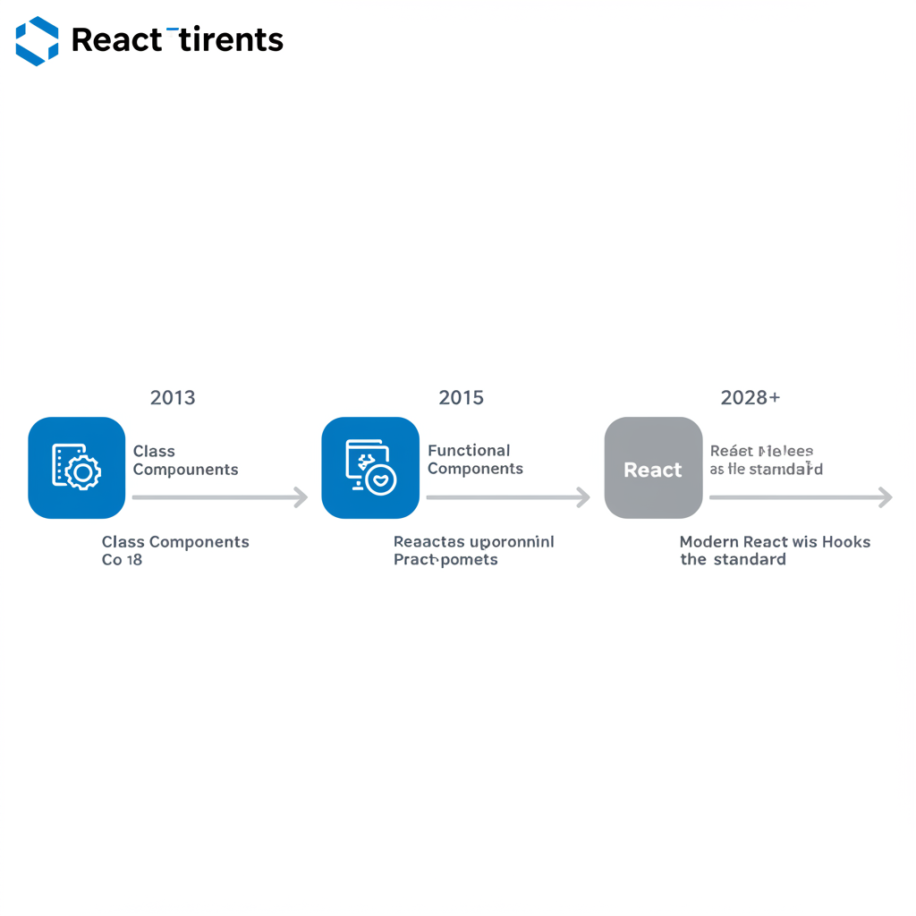**

**What are React Hooks?**Hooks are built-in functions in React that allow you to “hook into” state and lifecycle features in functional components. They eliminate the need for class components and provide a cleaner syntax.  
**Key Hooks Overview:**

* **useState**: Manage local state within a component.
* **useEffect**: Perform side effects like data fetching, subscriptions, or DOM manipulation.
* **useRef, useMemo, useCallback**, and custom Hooks: Enhance performance and reusability.

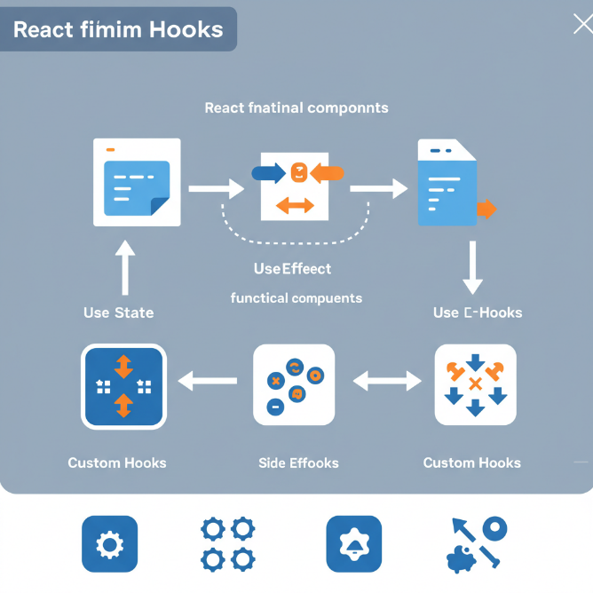

**B. Benefits of Using Hooks**

* Simplifies Component Logic: Hooks separate logic by concern rather than lifecycle methods.
* Reusability: You can build custom Hooks that encapsulate common logic to reuse across multiple components.
* Improved Readability & Maintenance: Code becomes easier to follow and maintain due to fewer boilerplate lines.

**C. Setting Up Your Environment**

* Dependencies: Ensure you have React 16.8 or later.
* Create a New Project:

**npx create-react-app my-hooks-app  
cd my-hooks-app  
npm start**

* Debugging Tools: Use the React Developer Tools extension for Chrome/Firefox to inspect Hooks in components.

**II. Common Challenges with React Hooks**

**A. State Management Issues**

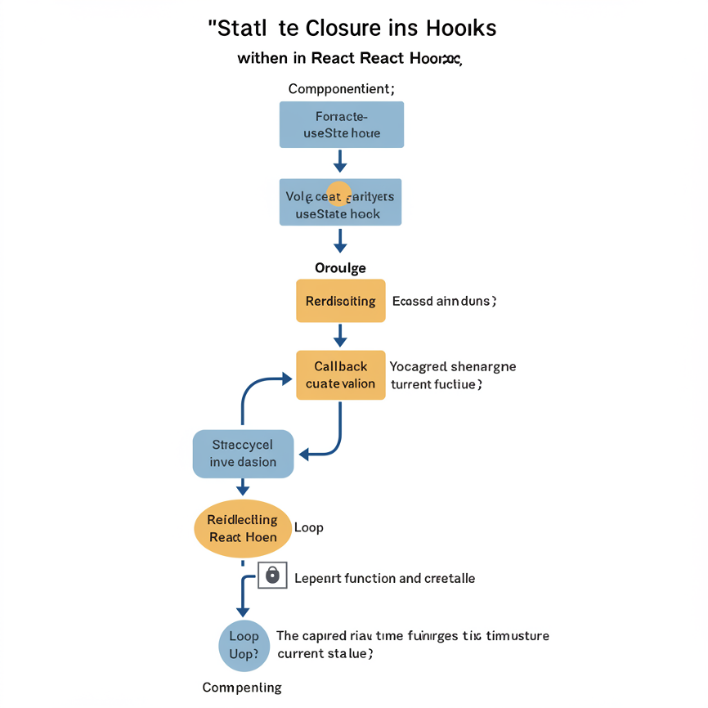

Closure Pitfalls and Stale State  
Using outdated state values inside closures can lead to bugs. Use the functional update form:  
**setCount(prev => prev + 1);**  
Dealing with Complex State  
When state has nested structures, use useReducer instead of useState for more predictable updates.  
Managing State Across Components  
Use context (useContext) or libraries like Redux or Zustand when state needs to be shared globally.

**B. Performance Concerns  
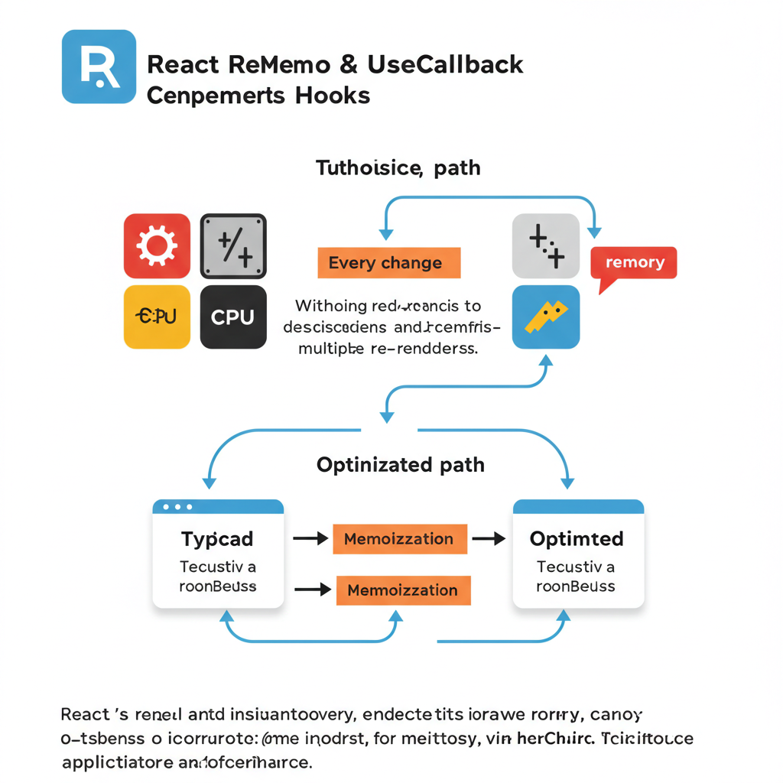**

Excessive Re-renders  
Hooks like useEffect and useState can trigger unnecessary renders. Use React.memo, useCallback, and useMemo to avoid costly operations.

Heavy Computations in useEffect  
Avoid placing expensive logic directly in useEffect. Move it to a useMemo or separate utility function.

Memoization Strategy Use:

**const memoizedValue = useMemo(() => computeHeavyTask(input), [input]);**

**C. Side Effects and Cleanup  
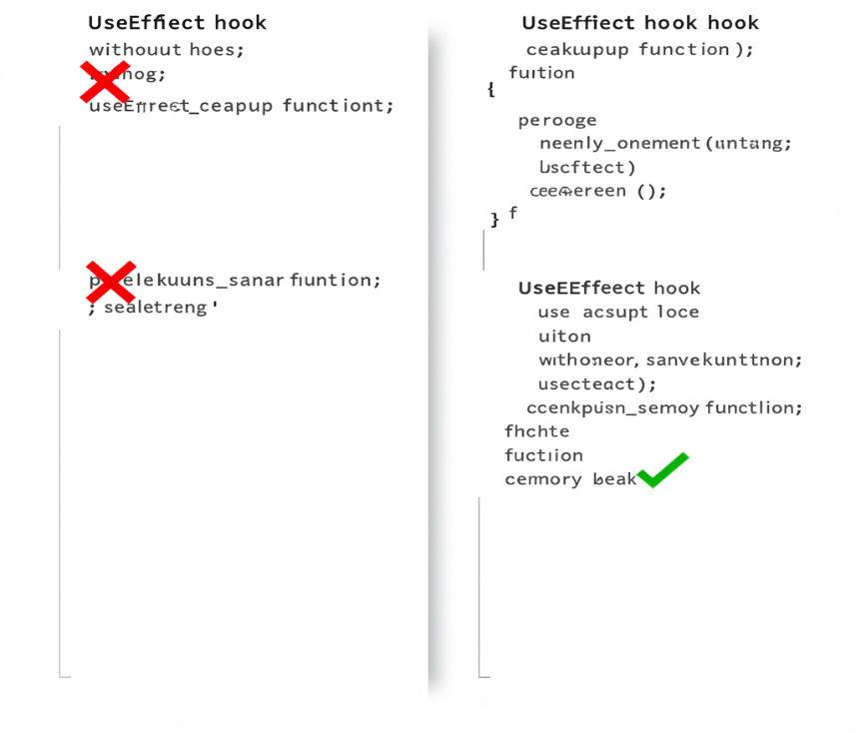**

Proper use of useEffect  
Always declare dependencies and avoid doing too much in one useEffect.

Cleanup Functions  
Avoid memory leaks with cleanups:

**useEffect(() => {**

**const subscription = subscribeToEvent();**

**return () => subscription.unsubscribe();**

**}, []);**

**Managing Async Operations  
Cancel async effects:  
useEffect(() => {**

**let isMounted = true;**

**fetchData().then(data => {**

**if (isMounted) setData(data);**

**});**

**return () => { isMounted = false; };**

**}, []);**

**III. Common Mistakes Made with Hooks**

**A. Rules of Hooks**

* Only call Hooks at the top level
* Only call Hooks from React functions Violating these leads to unpredictable behavior. Use ESLint’s eslint-plugin-react-hooks to catch violations.

**B. Mismanagement of Dependencies**

* Missing or wrong dependencies in useEffect often leads to stale values or infinite loops. Use:

**useEffect(() => {**

**doSomething(a, b);**

**}, [a, b]);**

Avoid overusing useEffect  
Sometimes logic can be derived directly in render or handled with derived state instead.

**C. Class vs Functional Component Confusion**

Lifecycle Mismatch  
**Understand that useEffect(() => {}, [])**   
is not a perfect substitute for componentDidMount. Be aware of execution order.

Avoid Hybrid Patterns  
Don't mix class-based patterns into functional components. Stick with Hooks entirely for clarity and consistency.

**IV. Best Practices for Using React Hooks**

**A. Structuring Your Application**

* Group related logic in custom Hooks.
* Separate UI from business logic using dedicated hooks and components.
* Example custom hook:

**function useWindowWidth() {**

**const [width, setWidth] = useState(window.innerWidth);**

**useEffect(() => {**

**const handleResize = () => setWidth(window.innerWidth);**

**window.addEventListener("resize", handleResize);**

**return () => window.removeEventListener("resize", handleResize);**

**}, []);**

**return width;**

**}**

**B. Testing Hooks**

**Tools: @testing-library/react-hooks, Jest, Vitest  
Test interactions and custom logic easily:**

**const { result } = renderHook(() => useCounter());**

**act(() => result.current.increment());**

**expect(result.current.count).toBe(1);**

**C. Learning and Adapting**

* Stay updated with changes in the React docs and roadmap.
* Follow the React blog and GitHub discussions.
* Share knowledge in teams through code reviews and pair programming.

**V. Resources and Additional Learning**



**A. Official React Documentation**

* <https://reactjs.org/docs/hooks-intro.html>
* <https://reactjs.org/docs/hooks-rules.html>
* Community-curated FAQ and blog examples

**B. Popular Libraries & Tools**

* React Query / TanStack Query – Data fetching with caching and syncing
* Zustand – Minimalistic global state management
* React DevTools – Hooks inspection and profiling

**C. Community & Forums**

* Join the [Reactiflux Discord](https://www.reactiflux.com/)
* Engage on Stack Overflow and Reddit’s r/reactjs
* Attend meetups and conferences (online/offline) like React Summit, React Conf

**Conclusion**

React Hooks are a game-changer—but they come with their quirks. From managing state and side effects to understanding the rules and avoiding performance issues, developers need to be mindful while using them. By staying informed, writing clean reusable logic, and embracing best practices, you’ll be well on your way to becoming a Hooks pro.

**FAQs**

1. What are the main benefits of using React Hooks?  
Hooks simplify code, reduce boilerplate, and promote reusable logic in functional components.

2. How do I manage state effectively with Hooks?  
Use useState for simple states, useReducer for complex logic, and context or global stores for shared state.

3. What should I do if my components are rendering too often with Hooks?  
Optimize with React.memo, useMemo, and useCallback. Profile using DevTools to identify bottlenecks.

4. How can I test my custom Hooks?  
Use @testing-library/react-hooks or test components that rely on your custom Hooks.

5. Are there any specific rules I should follow when using Hooks?  
Yes—Hooks must be used at the top level of functional components or custom Hooks and not inside loops, conditions, or nested functions.

